Exploration of fog detection and visibility estimation from camera images

Wiel Wauben and Martin Roth
R&D Observations and Data Technology
Royal Netherlands Meteorological Institute (KNMI)
P.O. Box 201, 3730 AE De Bilt, The Netherlands
email: Wiel.Wauben@knmi.nl and Martin.Roth@knmi.nl

Abstract
In this report several methods to assess the visibility from camera images during daytime are implemented and evaluated. The landmark discrimination method by using edge detection and visibility estimation from contrast attenuation between two targets. Two limited sets of images under varying visibility conditions were used. The first method recognized 26 cases out of a first set of 37 images correctly and 6 cases out of a second set of 7. The main cause of faulty recognitions was the threshold to determine strong edges. The second method yielded results which were in fair agreement with data from local present weather sensors on a clear day. For low visibility conditions (foggy day) the visibility was significantly overestimated due to lack of suitable (still visible and dark) objects. Bright targets resulted in a severe underestimation due to lower contrasts with respect to the background sky.

1. Introduction
Visibility is a meteorological variable which is important for the safety and capacity of road and air traffic. Visibility is defined as the greatest distance at which a black object of suitable dimensions, situated near the ground, can be seen and recognized when observed against a background (WMO, 2016). Traditionally visibility was estimated manually by observers using visibility markers at known distances. In these situations the reported visibility is partly determined by the availability of suitable visibility markers such as buildings and other objects during day-time and lamps at night. Physically, visibility can be defined in terms of the transparency of the atmosphere, which is reduced due to scattering and absorption by molecules and particles. The transparency or transmittance of the atmosphere is related to the atmospheric extinction. The transmittance can be measured using so-called transmissometers that measure the attenuation of a light source with known intensity over a fixed distance. By definition the visibility (Meteorological Optical Range) is the distance required to reduce the intensity of a light source to 5% of its original value. The relationship between the visibility (MOR) and the atmospheric extinction coefficient σ is given by MOR=-ln(0.05)/σ≈3/σ. KNMI uses a transmissometer as a reference instrument for visibilities up to 2 km at the test field in De Bilt. So-called forward scatter sensors are employed in the meteorological network of KNMI to determine the atmospheric extinction by the amount of scattering, assuming extinction is mainly caused by scattering. Visibility can be accurately measured by transmissometers and forward scatter visibility sensors, but these sensors are rather costly and the sample volume of these sensors is small. Therefore the measurements are representative for a small area only whereas visibility can vary largely on a small spatial scale. Hence a meteorological measurement network is generally not dense enough to detect all occurrences of fog.
Nowadays cameras are widely used for various applications such as security, supervision, traffic, construction and tourism and images are readily available on internet. Furthermore, image processing software is available for the interpretation of these images. Visibility extracted from camera images has therefore the potential to provide useful information. KNMI operates visibility sensors at about 25 automatic weather stations throughout The Netherlands while Rijkswaterstaat (the Dutch road authority) has about 5000 traffic cameras along the motorways and near tunnels, bridges etc. (see Figure 1). Using existing cameras, even if they are not evenly distributed around the country, is an efficient means to obtain additional information on visibility or fog. It is a so-called big data application and is of mutual interest of meteorological institutes and road authorities. In this paper an exploration of applying image processing techniques to camera images in order to study the feasibility of deriving visibility has been performed. The exploration considers fog detection as well as a quantitative estimation of the visibility. Several methods have been considered to derive visibility such as; (i) edge detection; (ii) contrast and (iii) dehazing techniques. The techniques have been applied to camera images that are available at some KNMI measurement sites and compared to the visibility measurements. Preliminary results of this exploration are presented below.
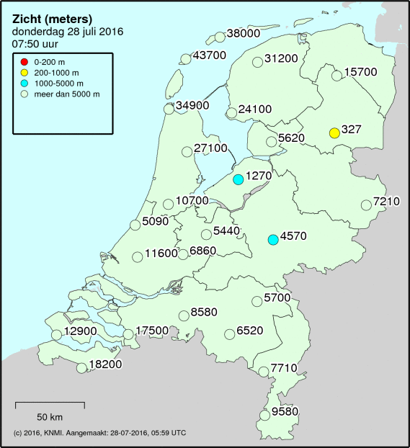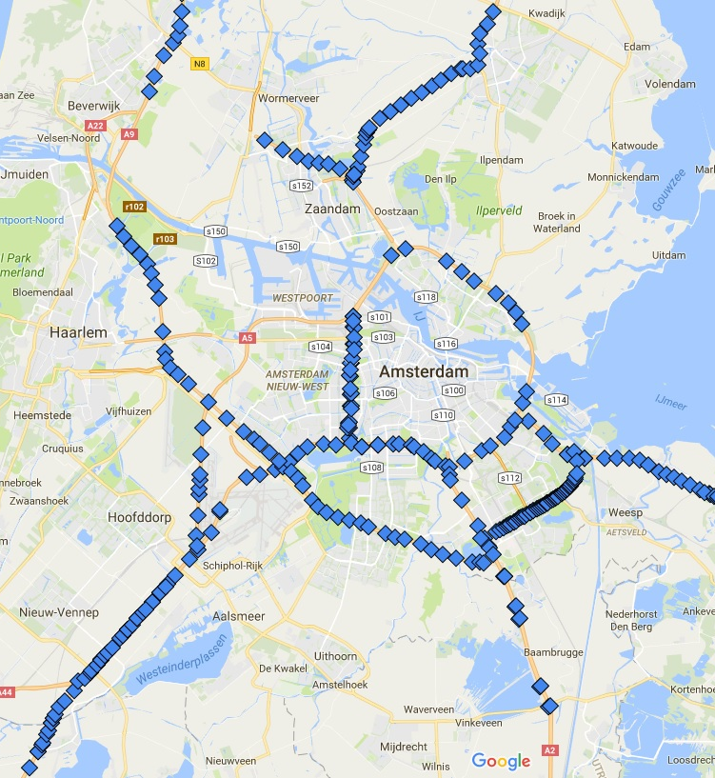
Figure 1: Overview of the automatic weather stations in The Netherlands measuring visibility (left) and the location of traffic cameras of Rijkswaterstaat around Amsterdam.

2. Sites and Camera images
Although camera images are readily available on internet, there is generally no archive of these images that can be used for analysis. The exploration also required that reference visibility values are available for the evaluation of the results. Therefore the exploration is restricted to KNMI sites equipped with visibility sensors and cameras. The sites considered are the test field at the main premises of KNMI in De Bilt (WMO number 06261); the automatic weather station (AWS) Twente (06290) and Amsterdam Schiphol Airport (06240). The test field in De Bilt is equipped with a AXIS 214 PTZ network camera that takes images of several sensors under test every 10 minutes. An overview of the test field is obtained with 1x zoom looking north with a horizontal viewing angle of about 50°. The image with a 768x576 resolution is stored in JPEG-format. The overview images of the test field (see Figure 2, left) show several sensors in the foreground including the forward scatter visibility sensor. In the background the radiosonde shed, the main building of KNMI and the radar tower are visible. The automatic weather station Twente is equipped with a fixed AXIS P3364 network camera with a horizontal viewing angle of about 80° and a resolution of 1280x960. The camera at AWS Twente is intended for monitoring the AWS site and its sensors and is mounted on the wind mast looking downwards to the southeast. Hence the image shows only a small fraction of the sky and the horizon is distorted. Again an image is available every 10 minutes. The camera at Schiphol is a Sony SNC-VB630 fixed network camera. It is located east of runway 18R looking northwest towards touchdown. These images are available every second through a Milestone video server. Unfortunately images could not be exported from the server so that in this paper only some screenshots are used for the exploration (see Figure 5).
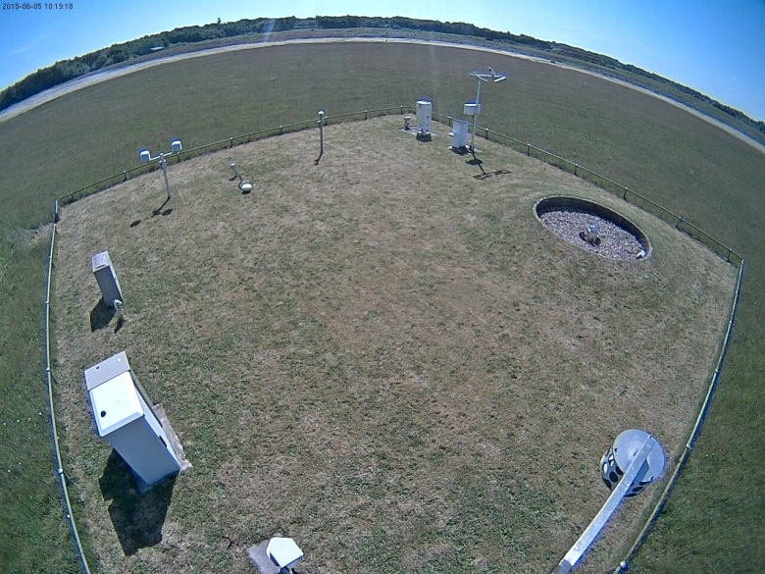
Figure 2: Example of an image of the test field of KNMI in De Bilt (left) and the automatic weather station at Twente (right). The forward scatter visibility sensor is denoted by the red rectangle.

3. Landmark discrimination - edge detection method
The first method considered is the landmark discrimination method using edge detection. The method resembles the way the visibility is estimated by human observers, i.e. by using a set of landmarks at known distances. The method is illustrated in Figure 3. The method requires some preparations. For each camera objects need to be identified on a clear image and the corresponding distances of these objects from the camera need to be determined. In the images of the test field in De Bilt the radiation sensors in the lower left at 17 m; the radiosonde shed at 108 m; the KNMI building at 170 m at the radar tower at 310 m have been selected for this purpose. Note also the tree line at the horizon could be used, but unfortunately there are no objects at large distances visible on this image. Next areas are defined around the selected objects. These areas, the yellow rectangles in Figure 3, are not closely fitted around the objects so that small misalignments of the camera have no effect. In these areas the number of edges will be determined (lower left panel). The edges are computed by convolution of the image with a Gaussian derivative with standard deviation of 1 (choosing a higher standard deviation notably decreases the number of edge pixels detected and a lower standard deviation makes the image too noisy). Subsequently, a threshold is set to determine the number of strong edge pixels which generally correspond with objects. The threshold was determined manually to correspond to the value of edge pixels on an image where a targets is just visible according to the operator’s perspective. The threshold thus obtained was an intensity of 5. Note that clouds and contamination on the dome covering the camera can also trigger strong edges. An object is considered visible if a sufficient amount of edges is contained in the area. Here a fraction of strong edge pixels inside the areas of 10% or more proved to be a good value. The results can be presented as shown in the lower right panel, that is a transparent red area indicates that the object is not visible whereas green denotes a visible object. The distance of the object is just above the rectangle.
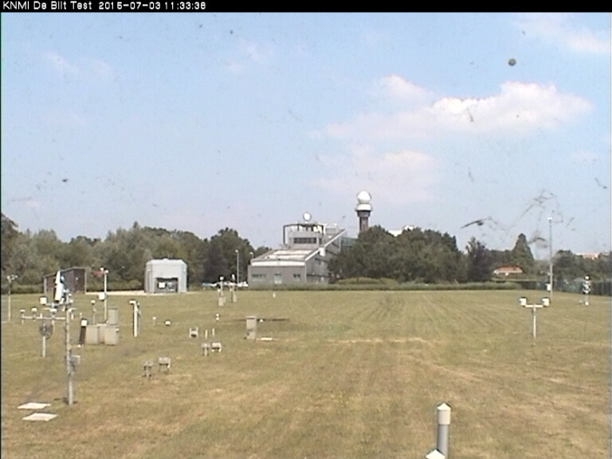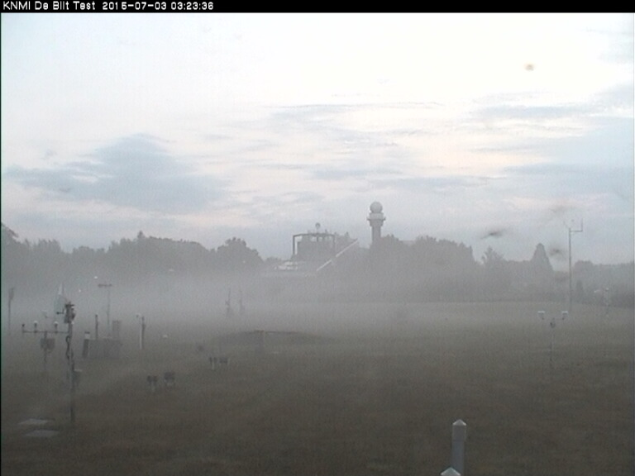
Figure 3: Illustration of the landmark discrimination method using edge detection showing the selected objects (top left), the image under evaluation (top right); the strong edges detected for that image (bottom left) and indication whether objects are visible (bottom right). The visibility reported by the forward scatter sensor is 272 m.
The landmark discrimination method using edge detection described above has been applied to images for De Bilt. Since there are no objects at large distance and the discrimination method only determines whether objects are visible or not the method can only be applied to situations with low visibility. Otherwise the method would only report that visibility is good (meaning above 310 m). Some results are given in Figure 4. The upper panel shows examples where visibility is good (left) or poor (right) when all objects are visible or none are visible. When visibility drops a situation as in the lower left panel can occur, indicating that the visibility is between 17 and 108 m. However, often situations occur when the estimated visibility is inconsistent (lower right) where the objects on the field indicate a visibility between 17 and 108 m, but the radar tower at 310 m is visible. Such situations can occur during shallow fog or in case of fog banks or patches. In such situations the landmark discrimination method also works and indicates the situation is inhomogeneous. The requirements of the user should then be considered on what visibility should be reported in such conditions, e.g. lowest visibility. Also note that the visibility reported by the visibility sensor might not be representative for the situation at the test field. Hence a manual evaluation by visual inspection of images around fog events has been performed. For De Bilt Test 37 images haven been manually evaluated and on 26 out of 37 images (=70%) all objects were correctly identified as visibility/non-visibility. Fog occurred in De Bilt Test on the mornings of July 3, 2015 and October 4, 2015 and the fog lifted at about 4:10 and 7:40 UT, respectively. This corresponds with the time that all objects become visible.
Figure 4: Examples of results obtained with the landmark discrimination method using edge detection for the camera at De Bilt Test. The visibility reported by the forward scatter sensor is 866 m (top left), 61 m (top right), 339 m (bottom left) and 122 m (bottom right).
The landmark discrimination method using edge detection has also been applied to images obtained at Schiphol using the same thresholds as derived for De Bilt Test. At Schiphol a lamppost, viaduct (both at 300 m) and two groups of trees (at about 1 km) serve as objects (see Figure 5). On the left image the atmosphere is clear and all the landmarks are visible in agreement with the results of the landmark discrimination method. The visibility sensor at 18R touchdown reported a MOR of 9340 m. The right image shows a situation with haze (sensor reported 3130 m). By visual inspection the group of trees on the left is still barely visible, while the method classifies this object as non-visible. On inspection of the change in intensity with position on the image, it turns out that in this region the change is too small in comparison with the threshold for edge strength. The object becomes visible again if the threshold is lowered to 2. The recognition of the landmarks on the other images obtained on November 2, 2015 were in agreement with visual inspection of the images. For Schiphol 7 images haven been manually evaluated and on 6 out of 7 images (=86%) all objects were correctly identified as visibility/non-visibility. The landmark discrimination results obtained at Schiphol indicate that the thresholds are quite good although there is room for improvement. Unfortunately, also at Schiphol no landmarks at large distances are available in the camera images to extend and test the discrimination method to larger visibility values.
Note that fog generally starts at night/in the morning and disappears after sunrise. Hence the number of fog cases is limited since daytime only is considered here. Fog can also be estimated by studying number of edges on the whole image and/or without detailed knowledge on objects and their distances. Also the number/strength of edges may give an estimate of the visibility. This is considered in section XX.
Figure 5: Examples of results obtained with the landmark discrimination method using edge detection for the camera at Schiphol. The visibility reported by the forward scatter sensor is 9340 m (left) and 3130 m (right).

4. Visibility estimation from contrast redcution between 2 targets
The second method that was considered estimates the visibility from the contrast reduction. Koschmieder’s law gives the relationship between the apparent contrast C(x) of an object at a distance x, seen against the horizon sky by an observer and its inherent contrast (C₀). The latter is the contrast that the object would have against the horizon when seen from very short range. Koschmieder’s relationship can be written as: C(x)=C₀ exp[-σx], with σ the extinction coefficient. C₀, a constant dependent on scene illumination and the properties of the object itself, that can be eliminated by comparing the contrasts of two objects with the same inherent contrast at different distances (x₁ and x₂). This results in C(x₂)/C(x₁)= exp[-σ(x₂-x₁)]. From this expression the extinction coefficient σ and thus the MOR can be estimated. Contrast quantifies the degree to which objects are visible based upon difference in brightness or colour. There are several ways to define contrast, but the most suitable one for visibility estimation is the so-called Weber contrast C=(I-I_{B})/I_{B} where I represents the intensity of the object under consideration and I_{B} the intensity of the background. The contrast of a nearby black object is high (C=-1) whereas in poor visibility conditions the object will fade into the background (C=0). Note that the contrast can also be determined for individual RGB channels and that the contrast is a ratio so that changes in illumination are, in a first order approximation, taken into account.
To illustrate this method the images obtained at De Bilt Test on August 1, 2015 are considered between 12 and 18 UT. During this period the visibility is good and conditions are homogeneous. For these images objects were chosen that have similar optical properties and which were sufficiently spaced. In the pictures below (Figure 6) two patches of trees were chosen and for the background a patch of the sky. On the same image also two other objects, namely the bright radar tower, a dark patch of trees and another patch of sky, were chosen. The pixel values were averaged over the selected areas to reduce spatial variations. From these pictures the visibility is obtained from the contrast reduction for each of the 3 colour channels (RGB) and for each of the 2 object pairs and is plotted in the right panel of Figure 6. The object pair using trees is indicated by the ‘trees’ curves in the legend and the pair using the radar tower and a patch of trees as targets is indicated by the ‘tower’ curves. For comparison the values of a forward scatter sensor, located at the same scene, are shown in the same figures. From the graphs it can be seen that there is a significant underestimation of the visibility obtained from the ‘tower’. When objects are not black or sufficiently dark, the derived visibility is frequently significantly underestimated since the added reflected light from these objects result in a lower contrast and thus a lower estimated visibility. Note that for the ‘trees’ the visibility is worst for the blue channel, while this colour has the highest estimated visibility for the ‘tower’ curves. When using similar dark objects, (trees) the visibility on this clear day is lowest for blue due to Rayleigh scattering, since shorter wavelengths are scattered more. Another point worthy of mentioning is that the green and red channels fluctuate more than the blue channel. This is mainly caused by the large fluctuations in the background sky in these channels. There is a clear dominance of red over the whole of each image of the test field at De Bilt. This is possibly due to the automatic white balance setting of the camera. Other objects that have been considered are buildings and grass. The results of the first are often affected by reflections, the latter by shadows and the position of the sun. Hence one has to be very careful in selecting suitable objects for the contrast reduction method.
Figure 6: Illustration of results obtained with the contrast reduction method using images obtained with the camera at the De Bilt Test field during good visibility conditions (left). The brown, blue and yellow rectangles denote the nearby object, farther object and background respectively. The derived visibility between 12 and 18 UT and the MOR reported by the forward scatter sensor is given (right).
The contrast reduction method was also used to estimate the visibility on a day with fog. The chosen objects now include part of a black pole nearby and trees. The visibility graph clearly shows a large overestimation of about a factor 6 in the early morning (5-7 UT) during fog. The main cause (aside from the general ones listed below) is non-suitability of objects. The trees were not visible in the morning, which makes them not suitable as target. However, there were no sufficiently dark objects available, which were still distinguishable at these low visibilities. Also notice the dip at around 10 UT for all three colours. This is caused by the sun casting shadows on the closest target. Note that the temporal and spectral variations of the visibility derived by the contrast reduction method in some situations is an indicator of possible problems for specific conditions.
Again the availability of suitable objects is essential for the contrast reduction method. A target is suitable if it’s sufficiently dark and large enough to be detectable by the camera. It is advantageous to choose the targets along a straight line. This reduces the influence of background stray lights and atmospheric inhomogeneity’s along the image. Furthermore, the distance to the near target and the distance between the targets should be large enough for sufficient attenuation of the target contrast. These two distances determine the visibility regime which can be detected within reasonable error. The error in the visibility increases when the visibility is much larger or much smaller than the distance between targets. In the first case the contrast reduction is too small and for the latter the object(s) fade into the background making it (them) not suitable for deriving the visibility. Besides the availability of suitable objects, images should have objects which are similarly illuminated by the sun. Inhomogeneous lighting is mostly caused by the change in position of the sun during the day and changes in cloudiness. In order to achieve this requirement a good approximation is to use images on which the sun is behind the camera on a relatively clear day. Overexposure also causes errors and should either be taken into account by the camera or these images should be left out of consideration as was done in this report.
Figure 7: As Figure 6, but during a period with fog.

5. Title
First paragraph.
Next paragraphs.
Figure 8: Legend.

X. Summary and Conclusions
The.
The.

Table 1: The.

Acknowledgements
It is our pleasure to thank Zubin and Alexander/Hans, SWI 2016, Andrea...

References
ICAO: Meteorological Service for International Air Navigation, Annex 3, 17th edition, International Civil Aviation Organization, Montréal, Canada, July 2010.
WMO: Guide to Meteorological Instruments and Methods of Observation, World Meteorological Organization No. 8, Geneva, Switzerland, 2014 Edition.

